**CONSTRUCTING METAPHORS FOR TOWNS IN LEXICON**

**Challenge:**Using Legos, clay, or any other 3-D sculpt-able material, **create a monument** for one of the towns in Lexicon. As you brainstorm ideas for your monument, it might help to consider monuments that already exist in our world. As you look at pictures of each of these monuments, consider the following questions:

1. What is the purpose of the monument? In other words, is it there to memorialize a particular event, remember a group of people,
2. How does the construction (e.g. shape, layout, use of space, size) of the monument reflect something about the event or place the monument is memorializing?
3. How does the monument’s color, texture, distance from or near to its visitors, etc. reflect something essential about the event or place it is memorializing?

[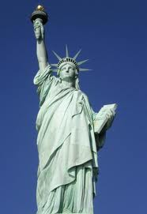](http://www.google.com/imgres?imgurl=http://www.visitingdc.com/images/statue-of-liberty-address.jpg&imgrefurl=http://www.visitingdc.com/new-york/statue-of-liberty-address.asp&usg=__OVWfe5nH7BtqR5DCVC_ctLqdw14=&h=540&w=371&sz=44&hl=en&start=0&zoom=1&tbnid=oh5kVI9Tk2HbeM:&tbnh=134&tbnw=92&prev=/images%3Fq%3DStatue%2Bof%2BLiberty%26hl%3Den%26biw%3D1276%26bih%3D541%26gbv%3D2%26tbs%3Disch:1&itbs=1&iact=hc&vpx=570&vpy=159&dur=1594&hovh=271&hovw=186&tx=98&ty=223&ei=hgj5TIyHEIK88gaRxaTjCQ&oei=bgj5TJX2FYH88AbDwsz-CA&esq=8&page=1&ndsp=17&ved=1t:429,r:12,s:0)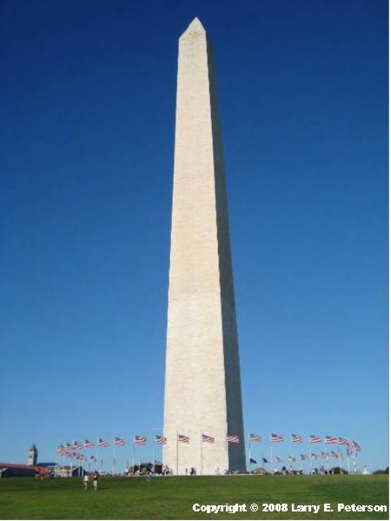

[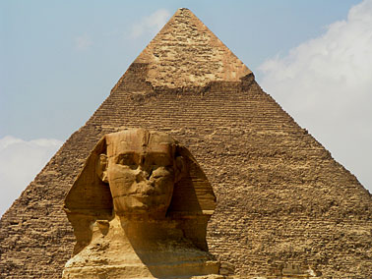](http://www.nationsonline.org/oneworld/map/Giza_Pyramids.htm)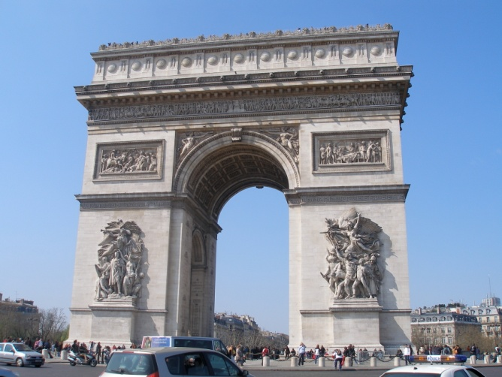

**MONUMENT PLANNING SHEET**

A monument is a type of structure created to commemorate a person, an important event, or a place. Older cities have monuments placed at locations that are already important or are sometimes redesigned to focus on one, and their purpose is very often to impress or awe. In fact, the word "monumental" is used in reference to something of great size and power. As you plan your monument for the town of Lexicon, answer the following questions in note form.

1. What town will your monument represent? What are the main characteristics, qualities, and values of your town?
2. What types of objects or colors or materials in our physical world could represent the values that the town holds most dear? (e.g. Ever think about why the Statue of Liberty is holding a torch? How does the literal torch spark (pun intended! ☺) thoughts of the USA’s values and principles? For each characteristic, quality, or value of your town, brainstorm a list of possible colors, objects, or materials that will allow you to suggest what the town values without directly tell us.
3. How does your town seem to view its environment? That is, do the townspeople spend a lot of time indoors or out? Do the people seem to prefer smaller, closed-in spaces or vast, open landscapes?
4. What’s the town’s history? In other words, what important events, people, or even weather patterns have made the town what it is? How does it view its history? With a sense of nostalgia? With a desire to forget it? With embarrassment? Pride? What materials, objects, symbols could you use to symbolize the town’s history as well as its feelings about its history?
5. How is your town laid out? Is it small and tightly packed, or expansive and open? How could you lay out a monument to reflect the town’s layout?
6. What are the people of your town like? What are their characteristics? What materials could represent their characteristics? (e.g. If you think that the people of Merry Measure are strong, perhaps you would consider steel, granite, or some other strong material with which to build.

**In the space below, sketch a provisional drawing of your monument. Label your drawing with at least 5-7 details about the way in which the materials, design, layout, etc. will reflect something essential about your town.**